A Personal Computer consists of these basic components...
Case with Power Supply:  __________________________________________________________________  __________________________________________________________________  The power supply is usually found built into the case and it is used to convert AC current (from a wall plug) to DC current (PCs use 3.3 volts, 5 volts and 12 volts)  There are various models of the case:  - _____________________________________________________________  - _____________________________________________________________  The power supply can be AT or ATX which determines the power saving and automatic shut off (and sleep state) options on the computer. |  |  | 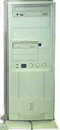  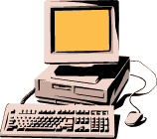
CPU (Central Processing Unit) or Processor  ________________________________________________________________________  _________________________________________________________________  There are two types of CPUs  - CISC = Complex Instruction Set Computer  ex: Intel (286, 386, 486, Pentium class), AMD, Cyrix  - RISC = Reduced Instruction Set Computer  ex: Power PC, SUN sparc, Motorola, Mac  * The speed of a processor is measured in MegaHertz (MHz) or GegaHertz |  |   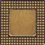
The Motherboard  ______________________________________________  ______________________________________________  ______________________________________________  - __________________________________  - __________________________________  - __________________________________  - __________________________________  - __________________________________ | 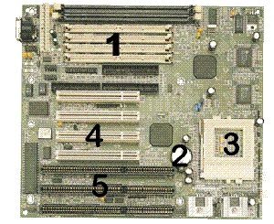

Expansion Slots: the interface between the motherboard buses and the peripheral devices (add in boards) A set of slots /sockets found on the motherboard where you can connect peripheral devices.  Usually the peripheral cards like sound cards, modems, and video cards plugged into them. Different computers have different numbers and types of slots, which determines how many extra devices (toys) you can add. | 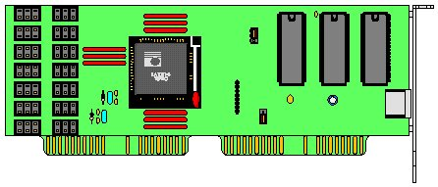
Memory: _________________________________________________________  There are several very different types of memory called ROM and RAM and CACHE.  ROM (Read Only Memory) _____________________________________________________  _____________________________________________________  _____________________________________________________  RAM (Random Access Memory)  _____________________________________________________  _____________________________________________________  _____________________________________________________  - SIMM ram (Single Inline Memory Modules)  - EDO ram ( 72 pins)  - SDRAM(168 pins - comes in different speeds) PC100 and PC133 RAM  - RDRAM (used on Pentium 4 computers) |  | 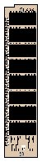
Cache RAM
______________________________________________________________
______________________________________________________________
______________________________________________________________
______________________________________________________________
The size of the PC's memory is measured in:
- bytes (one character or a letter, number etc)
- Kilobytes (1,024, bytes)
- Megabytes (1,048,576 bytes)
- Gigabytes (1,073,741,824 bytes)
- Terabytes (1,099,511,627,776 bytes)
From a user's point of view, the size of the RAM memory is very important as programs are loaded into RAM. If the amount of available RAM is small, you will not be able to run some larger programs.

Control Chips (Chip set): Controls the "traffic" on the two buses
- 1. I/O BUS for peripheral devices (Input / Output of data) and the
- 2. Memory BUS for moving information between memory and the CPU.

